**WORDMERGE DEPLOYMENT GUIDE**

1. **WordMerge Install**
2. Install the below files to: C:\Program Files (x86)\K2 blackpearl\ServiceBroker

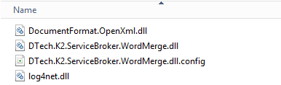

Note: Create a MergeBroker.log file if it doesn’t exist already and place on the directory below.

*C:\Program Files (x86)\K2 blackpearl\ServiceBroker\logs*

1. Register Service Type

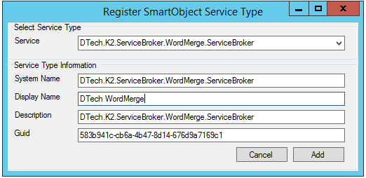

1. Register Service Instance

